User Guideline document

Welcome to system storage management. Storage management system use to manage all the material in storage. For this system have two role of user are Admin and normal user. Admin user can control everything in this system like put list of materials in the system and create user also. Normal user can view all data of material in the system and request the material in system from admin. Admin can get request or cancel the request.

1. Admin user

When the user login into system, the system will show all the list of material or we can call dashboard as the picture:

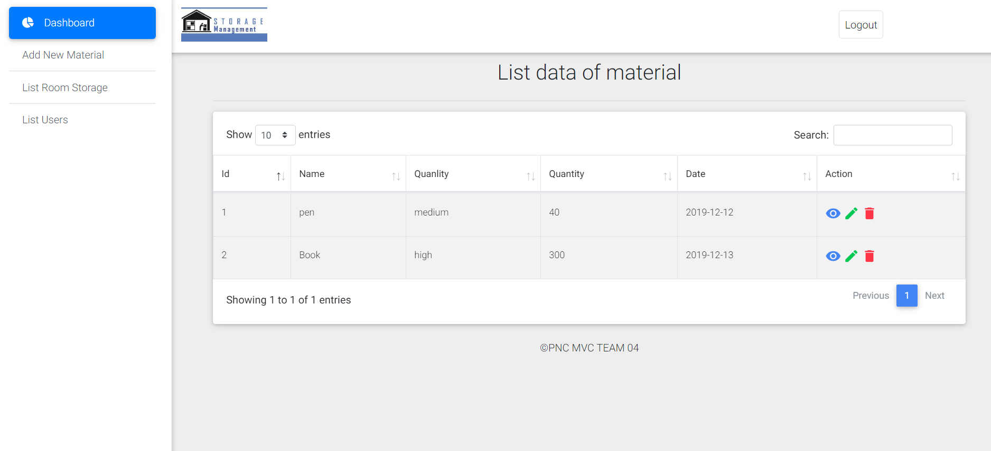

* Add materials into system

For add materials into system we have one button to add material on side navbar as the picture:



We can click on this button and then system will show the form for put the information of material such as name quantity quality, room and date that put those material into the storage as the picture:

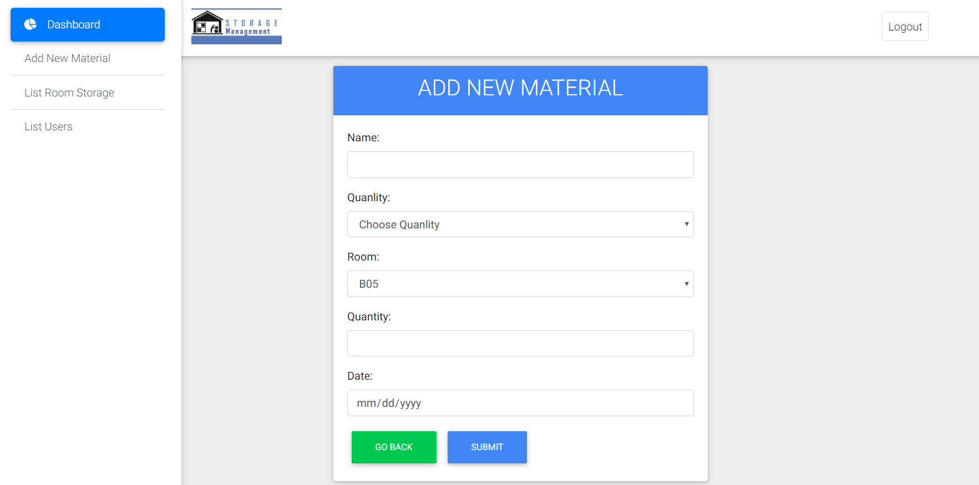

Before we click on button submit we need to fill all the input field then we will see the view of dashboard again.

On the column action user admin can view, update, or delete which material that they want as the picture:



* Create user into system

Admin user can create user in system by click on button list of user on sidebar of system then system will show you about the list name of user that have in the system with one button is the button create new user picture:



Then you will see the list of user that have into system:

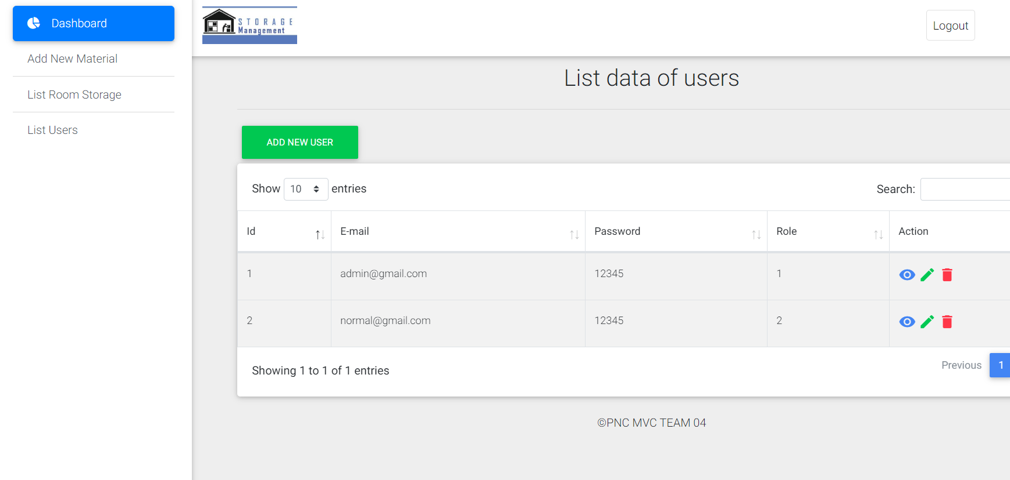

Click here

When you click on this button, it will show you the form to create new of user that have field email and password also.

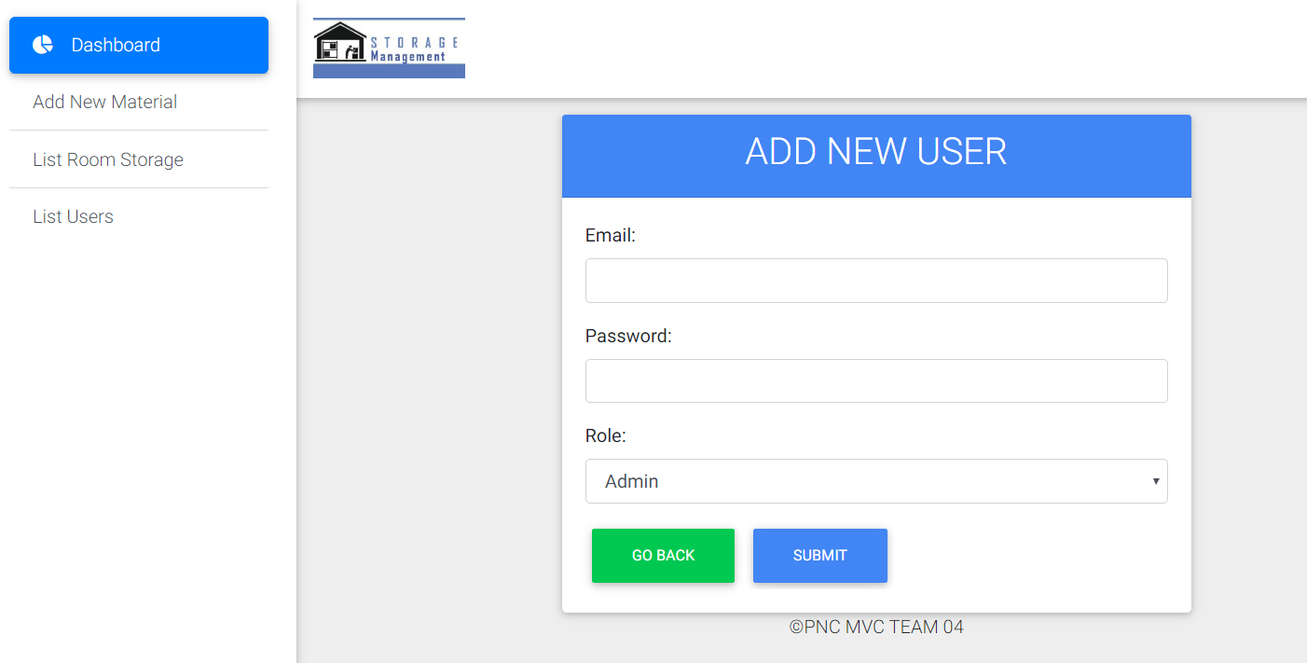

* Create room

Admin user can create room of storage by click on the button sidebar under the button list of user then you will see the button to create room. You can click on it, it will show the form to input the information of room such as name of room, floor of room and some description if you have.



Click here

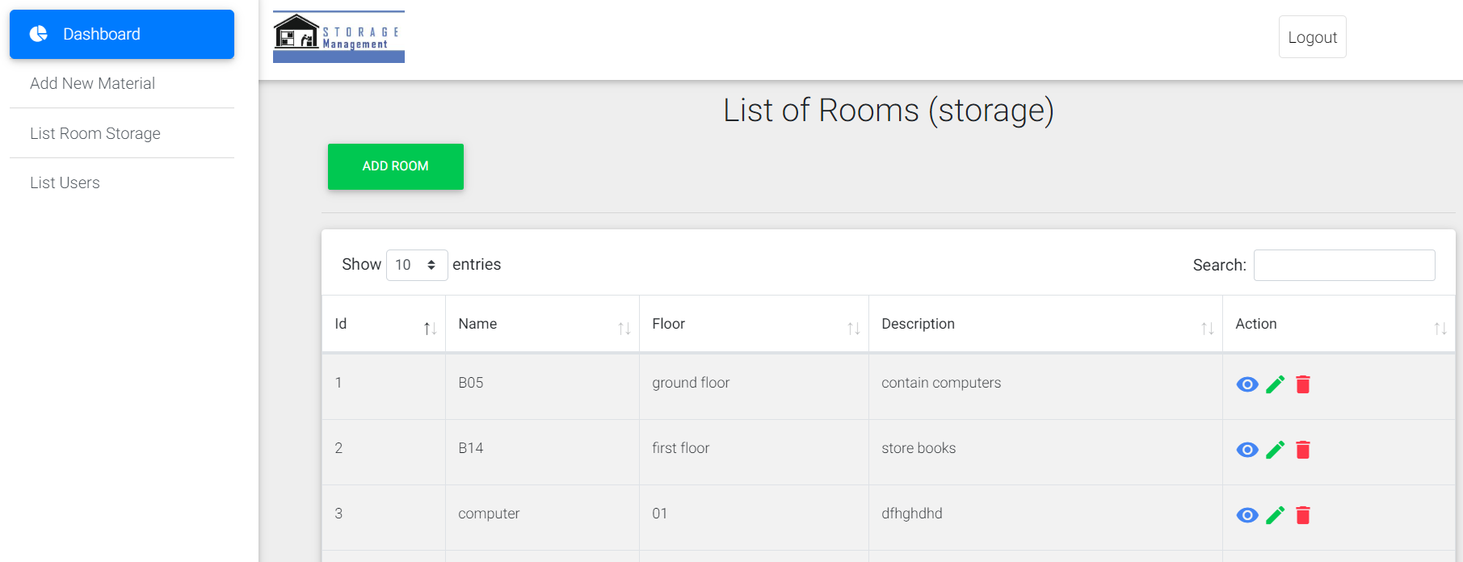

Click here

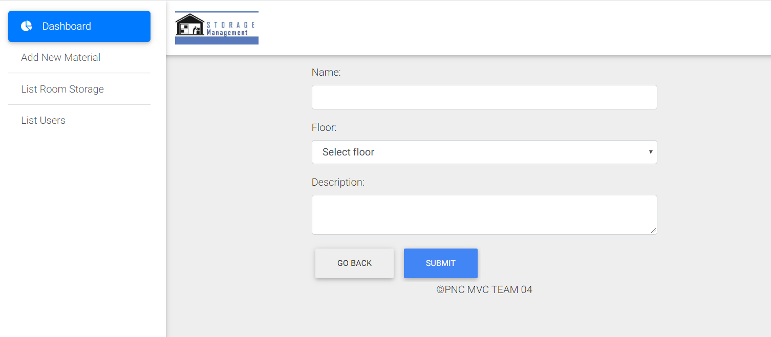

Click here

1. Normal user

When you are login by user normal the first time you will see the dashboard of user normal as the picture:

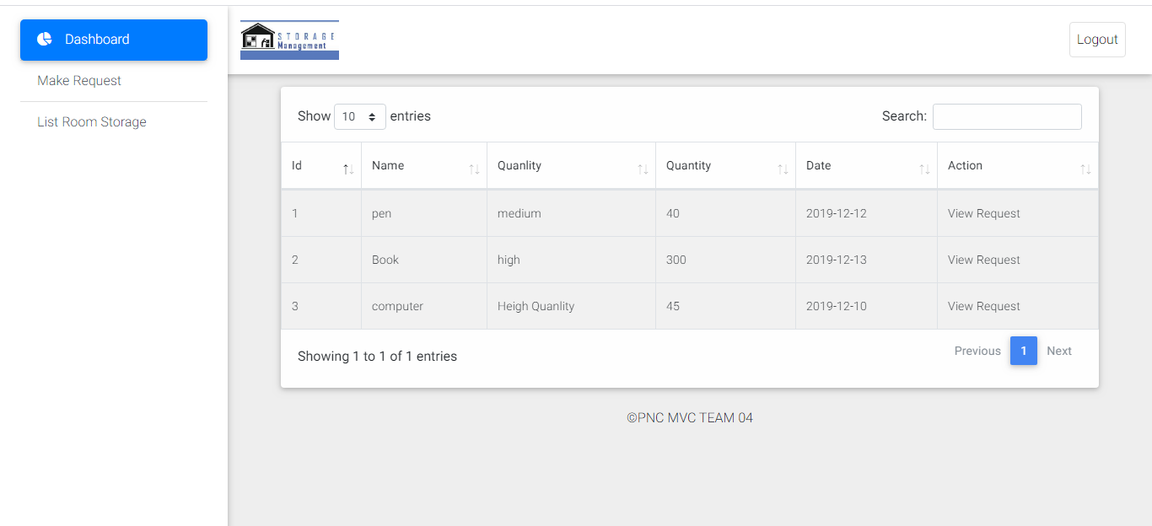

Then you can do some action as will descript below:

* Make the request Materials

You can make the request by on the button make request on sidebar of the system:



Or you can click on each material in the table on the link request in column action. You will can request the material also.



Before you make request if you want to know detail on each material you can click on view link on column action also.



* View room in the system

The user normal can also view the rooms that have in the system. We can click on the button list room storage.



Then you will see the table that show about data of the room in the system.

